Savings Program

ü Reserve ahead and save
ü Lowest rates available on the app or online
ü Optional detailing and oil change services
ü Complimentary EV charging at select locations

Reserve and Save on Airport Parking

With a network that spans coast-to-coast, Park’N Fly is focused on providing our customers with cost-effective parking options while enjoying a park happy experience with every stay. To access your member discount and save you have three options:
- Reserve via Park’N Fly App: Easily reserve your next parking stay using the Park’N Fly app and get the lowest rate! Plus, save your payment information to your reservation and you’ll be able to check in and out from the convenience of the app. Download today or click to learn more at www.parknfly.ca/app.  - Reserve as a Rewards Member: Existing Park’N Fly Rewards members can sign into your rewards account and start getting the lowest parking rates by adding your corporate discount code to your profile. Sign into your account via the Park’N Fly Canada app or online at www.parknfly.ca/rewards.  Not a Park’N Fly Rewards Member? Enroll today by clicking Join Now and start earning free days. Plus, Aeroplan members also earn 50% more Aeroplan points when you add your member number in your Park’N Fly Rewards profile.  - Reserve Online: Click RESERVE ONLINE (to the right), select your preferred location, and enter your travel dates and times to reserve your next parking stay. | Enter Discount Code  1120362  and Reserve  RESERVE ONLINE

Vancouver • Edmonton • Winnipeg • Toronto • Ottawa • Montreal • Halifax

www.parknfly.ca
Park’N Fly Rewards Program not applicable in Halifax. Association Rates are discounted off regular rates. Various conditions apply. Rates are subject to change. Please visit parknfly.ca and enter your discount code to validate rates. *Taxes, surcharges, and car care services excluded from corporate pricing. Aeroplan not available at Montréal location. ®Aeroplan is a registered trademark of Aeroplan Inc., used under license. ®The Air Canada maple leaf logo is a registered trademark of Air Canada, used under license. Park’N Fly is a registered trademark of 1884901 Alberta Ltd. Updated May 2022.
Mobile App
www.parknfly.ca/app
Take Control of Your Next Parking Stay from the Palm of Your Hands  The new Park’N Fly app puts you in control of your parking experience, making it easier and faster! Plus, you’ll always get the best rate by adding your corporate discount code to your reservation.  Here are four things you’ll love about the app:  - Reserve: Book your parking stay with just a few clicks  - Scan and Park: Check in quickly and safely with touchless scan technology all from the comfort of your mobile device  - Pay’N Go: Add payment details anytime to pay with the app and by-pass the counter or paystation  - Email Receipts: No more paper receipts to worry about, your receipt is sent directly to your inbox  While using the Park’N Fly app, Park’N Fly Rewards customers can stay connected with their rewards account and:  - Manage your account  - View your electronic rewards card  - Track your Park’N Fly Rewards points and earning activity  - Reserve and redeem instantly for free parking  - Plus, enjoy all the other benefits of scanning, parking, and paying all through the convenience of your mobile device  If you’re not a Park’N Fly Rewards member, install the app and enroll in the Park’N Fly Rewards program. It’s free to join and you’ll start  earning points towards free stays with every eligible  reservation!  Install the Park’N Fly app and reserve your next stay.  Watch our 30 Second Commercials  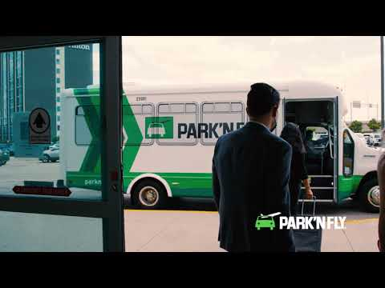 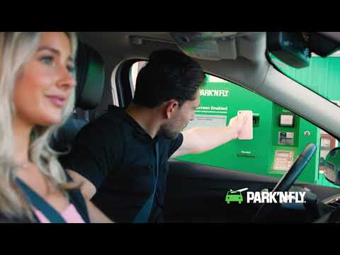  Self Park  Valet | 